1 Proposed Title:

Machine Learning-Assisted Prediction and Operating-Window Identification for HPHT Energised Foam Rheology

Proposal Summary
Hydraulic fracturing operations in high-pressure, high-temperature (HPHT) reservoirs require stable energised foams with predictable rheological behaviour to ensure effective proppant transport and fracture conductivity. However, conventional empirical approaches are constrained by limited experimental data, complex nonlinear fluid behaviour, and the absence of reliable methods for identifying optimal operating conditions.
This research proposes an uncertainty-aware machine learning framework to predict the rheological properties of HPHT energised foams and identify engineering operating windows for hydraulic fracturing-fluid design.
The study integrates experimental data compilation, predictive modelling, uncertainty quantification, optimisation, and engineering assessment within a petroleum engineering research methodology. Machine learning serves as a decision-support tool rather than the primary focus, ensuring that engineering judgement remains central throughout the investigation.
The expected outcome is a robust predictive framework that improves engineering decision-making, supports hydraulic fracturing-fluid formulation under HPHT conditions, and provides a foundation for future laboratory validation and field-scale application, thereby contributing to both petroleum engineering practice and research

Table of Contents
Proposal Summary 2
List of Figures 5
List of Tables 6
List of Abbreviations 7
2. Background and Petroleum Engineering Context 8
2.1 Hydraulic Fracturing and the Role of Energised Foams 8
2.2 Foam Rheology under HPHT Conditions 8
2.3 Foam Quality and Rheological Models 9
2.4 Nanoparticle–Surfactant Interactions 10
2.5 Proppant Transport and Engineering Performance 10
2.6 Critical Synthesis of the Existing Literature 11
3. Research Problem 12
4. Knowledge Gap and Significance 13
4.1 Knowledge Gap 13
4.2 Significance of the Research 15
5. Aim, Objectives, and Research Questions 16
5.1 Aim 16
5.2 Research Questions 16
5.3 Research Objectives 16
6. Proposed Methodology 18
6.1 Introduction 18
6.2 Proposed Methodology Overview 18
6.2.1 Conceptual Framework of the Research Methodology 18
6.2.2 Engineering Modules of the Proposed Methodology 24
6.3 Data Compilation and Preparation 26
6.4 Rheology and Stability Prediction 31
6.5 Predictive Uncertainty Quantification 32
6.6 Operating Window Identification 33
6.7 Engineering assessment 34
7 Data Requirements and Feasibility 36
8. Expected Contributions 37
9. Scope and Limitations 39
10. Alignment with My Background 40
11. References 41

List of Figures
Figure 6.1: Challenges in HPHT Foam Rheology Prediction 19
Figure 6.2: Petroleum Engineering Research Methodology Framework 20
Figure 6.3: Petroleum Engineering Research Methodology 21
Figure 6.4: Machine Learning Model Development, Validation and Engineering Integration Framework 22
Figure 6.5: Integrated Engineering Workflow and Decision-Gate Framework for the Proposed Research Methodology. 25

List of Tables
Table 4.1. Critical Knowledge Gap Matrix 13
Table 6.1. Summary of Input and Output Variables for the Proposed Predictive Modelling Framework 27
Table 6.2 Dataset Standardisation Protocol 30
Table 6.3 Analytical Method Selection and Justification 29

List of Abbreviations

Abbreviation | Definition
AI | Artificial Intelligence
ANN | Artificial Neural Network
BO | Bayesian Optimisation
CV | Cross-Validation
DOE | Design of Experiments
DT | Decision Tree
EDA | Exploratory Data Analysis
GBDT | Gradient Boosting Decision Tree
HPHT | High-Pressure High-Temperature
LGBM | Light Gradient Boosting Machine
MAE | Mean Absolute Error
MAPE | Mean Absolute Percentage Error
ML | Machine Learning
MLP | Multi-Layer Perceptron
MSE | Mean Squared Error
NRMSE | Normalised Root Mean Squared Error
PDF | Probability Density Function
PVT | Pressure–Volume–Temperature
R² | Coefficient of Determination
RF | Random Forest
RMSE | Root Mean Squared Error
SVM | Support Vector Machine
UQ | Uncertainty Quantification
XGBoost | Extreme Gradient Boosting
CO₂ | Carbon Dioxide
N₂ | Nitrogen
HP | High Pressure
HT | High Temperature

2. Background and Petroleum Engineering Context
The performance of nanoparticle-stabilised energised foams under HPHT conditions depends on complex interactions between reservoir conditions, fluid formulation, rheological behaviour, and engineering requirements. Understanding these relationships provides the foundation for evaluating their application in hydraulic fracturing and identifying the limitations that motivate this research.

2.1 Hydraulic Fracturing and the Role of Energised Foams
The exploitation of unconventional reservoirs and mature fields presents operational and environmental challenges for conventional water-based hydraulic fracturing. Water-based stimulation requires substantial volumes of freshwater, while fluid invasion may contribute to clay swelling and formation damage, potentially reducing reservoir productivity in water-sensitive formations (Gonzalez Perdomo and Wan Madihi, 2022). Consequently, energised fracturing foams incorporating compressible gases such as nitrogen or carbon dioxide have emerged as alternative fluids for water-sensitive and under-pressured reservoirs (Wanniarachchi et al., 2017).
Energised foams can reduce water consumption while providing rheological properties that support proppant suspension and transport (Fei et al., 2018; Yekeen et al., 2018). Their engineering performance, however, depends strongly on maintaining suitable apparent viscosity and foam stability during fluid preparation, pumping, fracture propagation, and proppant placement. These properties are sensitive to interacting factors including pressure, temperature, foam quality, shear conditions, salinity, and chemical formulation. The principal engineering challenge is therefore not merely to generate a stable foam under controlled laboratory conditions, but to understand and predict how its rheological and stability characteristics change across the demanding and dynamic conditions of HPHT fracturing operations.

2.2 Foam Rheology under HPHT Conditions
The rheological behaviour of energised foams is strongly influenced by pressure, temperature, and shear conditions. These factors affect bubble structure, liquid drainage, apparent viscosity, and foam stability. Jing et al. (2019), for example, showed that increasing pressure alters gas-phase behaviour and bubble size, with corresponding effects on foam viscosity. Elevated temperatures have also been associated with faster liquid drainage and reduced viscosity and stability (Hutchins and Miller, 2005; Fu and Liu, 2021).
Although these studies provide important insights, their findings are often specific to particular formulations and experimental conditions. Fu and Liu (2021) and Lv et al. (2015), for example, examined foam behaviour at temperatures up to approximately 72°C and 90°C, respectively. While valuable, these experimental ranges do not capture the more extreme temperatures or the full range of coupled pressure and temperature conditions that may be encountered in HPHT reservoirs, which have been classified in previous literature as having temperatures above 150°C and pressures exceeding 69 MPa (Gonzalez Perdomo and Wan Madihi, 2022). Similarly, studies that vary pressure or temperature independently may not fully capture how these variables interact with foam quality, shear rate, salinity, and chemical formulation under reservoir conditions (Sinha et al., 2019).
The literature therefore establishes that operating conditions strongly influence foam rheology and stability, but the evidence remains fragmented across different formulations, experimental methods, and operating ranges. This limits direct comparison between studies and makes it difficult to generalise observed relationships across broader HPHT fracturing conditions.

2.3 Foam Quality and Rheological Models
Foam quality, expressed as the volumetric gas fraction, strongly influences foam structure and rheological behaviour. Increasing foam quality can increase apparent viscosity up to a critical range, beyond which rheological behaviour may change as the foam structure becomes increasingly gas-dominated (Akhtar et al., 2018). To describe the resulting non-Newtonian and shear-thinning behaviour, studies have applied rheological models such as the Power-law, Bingham plastic, and Herschel–Bulkley equations (Ahmed et al., 2017).
Although these models provide useful representations of foam behaviour within their calibration ranges, their empirical parameters may not remain transferable across different formulations and operating conditions. The complex and heterogeneous structure of high-quality foams further complicates representation using simplified constitutive relationships (Princen and Kiss, 1989). More recently, machine learning approaches, including XGBoost and Artificial Neural Networks, have been applied to capture nonlinear relationships in foam rheological data (Al-Darweesh et al., 2024). However, where the models examined provide only deterministic point predictions, uncertainty arising from sparse data, experimental variability, and extrapolation beyond the training range remains unquantified. This limits confidence in their application to engineering decisions under variable HPHT conditions (Zhang et al., 2025).

2.4 Nanoparticle–Surfactant Interactions
To improve foam stability under elevated temperatures, silica nanoparticles have been used to form interfacial barriers that enhance film elasticity and delay liquid drainage (Gonzalez Perdomo and Wan Madihi, 2022). Their stabilisation efficiency, however, depends strongly on interactions with the selected surfactant. For instance, combining negatively charged silica nanoparticles with cationic surfactants such as CTAB can induce strong electrostatic attraction, producing nanoparticle aggregates or “corks” that obstruct drainage channels (Tran et al., 2023). Studies have also reported higher apparent viscosity and stability for some cationic surfactant–nanoparticle systems than for comparable anionic mixtures (Tran et al., 2025).
This stabilising effect is highly concentration-dependent. Tran et al. (2022) reported that exceeding an optimal cationic surfactant concentration can induce excessive nanoparticle flocculation, causing particles to remain or precipitate in the bulk phase rather than stabilising the interface, with a corresponding decline in foam stability. These nonlinear and formulation-specific interactions create an important predictive challenge because relationships observed within one concentration range may not remain valid beyond it. Accurately identifying such thresholds is therefore important for predicting foam performance and defining candidate operating windows.

2.5 Proppant Transport and Engineering Performance
The effective suspension and transport of proppant into the fracture network are important engineering functions of energised fracturing foams. Compared with conventional slickwater, foams can provide rheological and elastic properties that support improved proppant suspension and distribution under certain conditions (Fei et al., 2018). Proppant settling is also influenced by fluid viscosity, making the maintenance of suitable rheological behaviour important for effective transport (Goel et al., 2002).
A critical limitation, however, is that elevated temperatures can degrade foam stability and compromise proppant suspension. Lv et al. (2015), for example, reported substantial increases in proppant settling velocity under elevated-temperature conditions. Because proppant transport is a downstream engineering consequence influenced by foam rheology and stability, uncertainty in predicting these primary properties may propagate into subsequent assessments of proppant behaviour and fracture performance (Tran et al., 2025). This reinforces the need to quantify predictive uncertainty when identifying candidate operating windows for further laboratory and engineering evaluation.

2.6 Critical Synthesis of the Existing Literature
The literature has established important relationships between HPHT conditions, foam quality, nanoparticle–surfactant interactions, rheological behaviour, and proppant transport (Gonzalez Perdomo and Wan Madihi, 2022; Tran et al., 2025). Conventional rheological models provide useful descriptions within defined experimental conditions (Ahmed et al., 2017), while data-driven approaches offer additional capacity to capture complex nonlinear relationships (Al-Darweesh et al., 2024). However, the evidence remains fragmented across different formulations, experimental methods, operating ranges, and measured outputs, limiting direct comparison and broader generalisation.
This fragmentation is compounded by small, formulation-specific datasets and limited coverage of coupled HPHT conditions (Sinha et al., 2019). As a result, models calibrated or trained on particular datasets may perform well within the conditions represented but provide limited evidence of reliability under sparse, unfamiliar, or extrapolated conditions. Where predictions are deterministic, uncertainty arising from experimental variability, limited data coverage, and model limitations may also remain unquantified (Ogbidi and Oteh, 2023).
The central challenge is therefore not simply the limited application of uncertainty-aware machine learning to foam rheology. Rather, existing approaches do not yet adequately integrate HPHT foam behaviour, predictive uncertainty, and engineering interpretation within a framework capable of supporting candidate operating-window identification. Addressing this limitation is important because fracturing-fluid design requires not only predictions of apparent viscosity and foam stability, but also an understanding of their reliability and implications for downstream engineering assessment (Tran et al., 2025).

3. Research Problem
Hydraulic fracturing operations in High-Pressure, High-Temperature (HPHT) reservoirs increasingly utilise energised foams to reduce water consumption, minimise formation damage, and support proppant transport (Wanniarachchi et al., 2017; Fei et al., 2018). Despite these advantages, maintaining suitable foam performance under HPHT conditions remains a significant engineering challenge. Elevated temperatures and pressures can influence liquid drainage, bubble coalescence, gas diffusion, and other physicochemical processes that alter foam rheology and stability (Gonzalez Perdomo and Wan Madihi, 2022).
Predicting this behaviour is difficult because apparent viscosity and foam stability are governed by coupled, nonlinear interactions among pressure, temperature, foam quality, surfactant chemistry, nanoparticle concentration, salinity, shear rate, and gas-phase characteristics (Al-Darweesh et al., 2024; Ghorbani, 2025). Consequently, a foam formulation that performs adequately under one set of experimental or operating conditions may not exhibit the same behaviour under different HPHT conditions.
The core engineering problem is therefore not simply that energised foam rheology is difficult to predict. Unreliable prediction of apparent viscosity and foam stability can compromise fracturing-fluid formulation and the identification of suitable operating conditions, with downstream implications for proppant suspension and transport, fracture conductivity, and overall treatment performance (Tran et al., 2025). Without sufficiently reliable predictions and an understanding of their uncertainty, engineers have limited confidence in determining how nanoparticle-stabilised energised foams will perform across variable HPHT conditions. This creates a need for a predictive approach that can model the primary rheological and stability characteristics of these foams while assessing the reliability of its predictions to support fracturing-fluid design and subsequent engineering evaluation.

4. Knowledge Gap and Significance

4.1 Knowledge Gap
Empirical and mechanistic models, including the Power-law, Bingham plastic, and Carreau models, have long been used to represent the rheological behaviour of energised foams under controlled experimental conditions (Al-Darweesh et al., 2024; Ghorbani, 2025). Although these models provide valuable insights into apparent viscosity and yield behaviour, their parameters and simplifying assumptions may not remain transferable across the coupled nonlinear interactions among pressure, temperature, shear rate, foam quality, surfactant chemistry, nanoparticle concentration, salinity, and gas-phase characteristics encountered under HPHT conditions. This limits confidence in their generalisation across different formulations and operating environments (Gonzalez Perdomo and Wan Madihi, 2022).
Recent studies have increasingly applied machine learning techniques, including Random Forest, XGBoost, and Artificial Neural Networks, to capture nonlinear relationships and predict foam rheological properties (Al-Darweesh et al., 2024; Ghassemzadeh et al., 2021). However, the available studies rely predominantly on laboratory-scale and formulation-specific datasets, with limited representation of diverse and coupled HPHT conditions. Their predictive performance is therefore closely tied to the conditions represented in the available data. Where models provide only deterministic point predictions, uncertainty arising from sparse data, experimental variability, and extrapolation beyond the training range remains unquantified.
Uncertainty quantification has been applied in other areas of petroleum engineering, including reservoir characterisation and production forecasting (Ogbidi and Oteh, 2023; Zhang et al., 2025), but its integration with predictive modelling of nanoparticle-stabilised energised foam rheology remains limited. Consequently, existing approaches provide limited information about prediction reliability under sparse, unfamiliar, or extrapolated HPHT conditions. This matters because uncertainty in predicted apparent viscosity and foam stability may affect the identification of suitable formulation and operating ranges and subsequent engineering assessments of proppant suspension and transport.
The limitations identified across existing rheological, experimental, and data-driven approaches are synthesised in the Critical Gap Matrix presented in Table 4.1.

Table 4.1. Critical Knowledge Gap Matrix
Existing Research | Primary Capability | Key Limitation | Engineering Implication | Key References
Empirical rheology models | Estimate apparent viscosity and yield stress | Simplified assumptions and limited applicability under HPHT conditions | Reduced confidence in fracturing-fluid design | Ahmed et al. (2022); Li et al. (2021)
Mechanistic models | Represent baseline physical behaviour | Limited representation of coupled nonlinear interactions | Reduced predictive reliability during hydraulic fracturing operations | Singh et al. (2023); Wang et al. (2022)
Random Forest / XGBoost models | Predict rheological properties | Predominantly laboratory-scale datasets and deterministic outputs | Limited generalisation to field-scale HPHT applications | Zhang et al. (2024); Liu et al. (2023)
Artificial Neural Networks | Learn complex nonlinear relationships | Limited model interpretability and absence of uncertainty estimation | Reduced confidence in engineering decision-making | Kumar et al. (2024); Chen et al. (2023)
Existing uncertainty quantification studies | Quantify predictive uncertainty in petroleum engineering applications | Limited application to nanoparticle-stabilised energised foam rheology | Limited support for risk-informed hydraulic fracturing design and operating-window selection | Ogbidi & Oteh (2023); Smith et al. (2024)
Source: Developed by the author. Note: The table synthesises the dominant research streams and engineering limitations identified from the reviewed literature. The representative references are illustrative rather than exhaustive and correspond to the studies discussed in Section 2
As shown in Table 4.1, the research gap is not attributable to a single methodological limitation, but to the lack of integration between HPHT-relevant data, nonlinear prediction, uncertainty quantification, and engineering interpretation.

4.2 Significance of the Research
Therefore, a significant scientific and engineering gap remains. Existing empirical, mechanistic, and data-driven approaches have not yet adequately integrated heterogeneous HPHT foam data, nonlinear prediction of apparent viscosity and foam stability, explicit uncertainty quantification, and engineering interpretation within a coherent framework. Addressing this gap requires an uncertainty-aware predictive framework capable of assessing model reliability across variable HPHT conditions and supporting candidate operating-window identification for further laboratory and engineering evaluation. Such a framework could support fracturing-fluid design by providing not only predictions of foam behaviour, but also an indication of the confidence and limitations associated with those predictions.

5. Aim, Objectives, and Research Questions

5.1 Aim
The primary aim of this doctoral research is to develop an uncertainty-aware predictive framework to support High-Pressure, High-Temperature (HPHT) energised foam design, utilising machine learning to predict apparent viscosity and stability, quantify uncertainty, and identify safe operating windows for hydraulic fracturing applications.

5.2 Research Questions
To achieve this aim, the research seeks to address the following technical questions:
- Which formulation and operating variables most strongly control the apparent viscosity and foam stability of nanoparticle-stabilised energised foams under HPHT conditions?
- How accurately can machine learning models predict apparent viscosity and foam stability across varying pressure, temperature, salinity, foam quality, and chemical formulation conditions?
- How can prediction uncertainty be quantified and incorporated into the interpretation of foam rheology models?
- How can uncertainty-aware predictions support operating-window identification for fracturing-fluid design and proppant transport assessment?

5.3 Research Objectives
The objectives of this research align directly with the research questions and the proposed methodology. Each objective is designed to yield a clear engineering deliverable:
To investigate the influence of pressure, temperature, fluid composition, and shear conditions on the rheological behaviour of energized foams under HPHT reservoir conditions.
- Compile and structure HPHT foam rheology and stability datasets from available experimental and literature sources.
- Develop and compare selected ML models for predicting apparent viscosity and foam stability indicators.
- Quantify prediction uncertainty and assess model reliability under sparse or extrapolated HPHT conditions.
- Identify operating windows for nanoparticle-stabilised energised foam formulations under defined reservoir and treatment constraints.
- Evaluate the engineering implications of the model outputs for fracturing-fluid design and proppant transport

6. Proposed Methodology

6.1 Introduction
This research proposes a data-driven workflow to predict and evaluate the rheological behaviour of nanoparticle-stabilised energised fracturing foams under High-Pressure, High-Temperature (HPHT) reservoir conditions (Gonzalez Perdomo and Wan Madihi, 2022). Rather than replacing physical engineering judgment, the machine learning frameworks proposed in this study are expected to serve strictly as advanced decision-support tools (Ghassemzadeh et al., 2021; Ogbidi and Oteh, 2023). The methodology is systematically designed to address complex petroleum parameters, integrating predictive analytics with the petroleum engineering assessment of foam stability, proppant suspension, and ultimate fracture conductivity (Fei et al., 2018; Tran et al., 2025).

6.2 Proposed Methodology Overview
To ensure methodological rigour and maintain the petroleum engineering focus of this study, the proposed methodology is presented through a series of complementary conceptual and methodological frameworks rather than a purely descriptive narrative. The use of multiple visual frameworks improves the communication of complex research designs by illustrating the logical relationships between the research problem, objectives, methodology, and expected outcomes, thereby enhancing transparency, coherence, and reproducibility (Maxwell, 2013; Creswell and Creswell, 2023).
This layered presentation also enables the reader to understand the progression of the research from problem identification to engineering application while demonstrating how machine learning is integrated as a supporting analytical tool within an engineering-led investigation.

6.2.1 Conceptual Framework of the Research Methodology
This subsection presents the conceptual frameworks underpinning the proposed research methodology. Rather than representing independent models, the four frameworks provide complementary perspectives of the study, illustrating the progression from problem identification and methodological alignment to engineering workflow and predictive model implementation. Together, they establish the conceptual foundation for the five engineering modules described in Sections 6.3–6.7.

Figure 6.1
Challenges in HPHT Foam Rheology Prediction

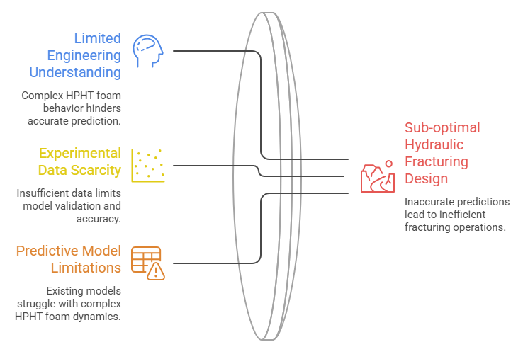

Source: Developed by the author Note: The figure synthesises the principal challenges affecting HPHT foam rheology prediction identified in the reviewed literature, including limited engineering understanding, experimental data scarcity, predictive modelling limitations, and operating-window uncertainty (Fei et al., 2018; Tran et al., 2025; Ogbidi & Oteh, 2023).

Figure 6.1 introduces the engineering problem by illustrating the principal challenges affecting the accurate prediction of HPHT energised foam rheology. These challenges include limited understanding of foam behaviour under HPHT reservoir conditions, scarcity of experimental data, and the limitations of existing predictive models. The figure demonstrates how these interconnected challenges reduce prediction reliability, resulting in uncertainty in operating-window identification and hydraulic fracturing design, thereby establishing the need for the proposed research.

Figure 6.2
Petroleum Engineering Research Methodology Framework

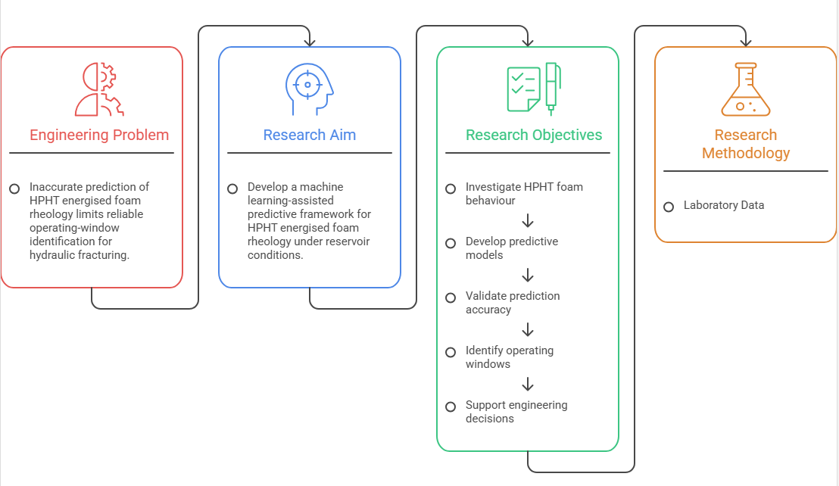
Source: Developed by the author. Note: Illustrates the logical alignment between the petroleum engineering research problem, research aim, objectives and outcomes. It is informed by established research design principles (Maxwell, 2013; Creswell & Creswell, 2023; Saunders et al., 2023).
Building upon this foundation, Figure 6.2 presents the Research Alignment Framework, illustrating the logical relationship between the engineering problem, research aim, research objectives, methodology, expected outputs, and anticipated contribution to knowledge. The framework demonstrates how each component of the research is aligned to ensure methodological coherence and internal consistency throughout the investigation, which are recognised characteristics of rigorous research design (Maxwell, 2013; Creswell & Creswell, 2023).

Figure 6.3
Petroleum Engineering Research Methodology

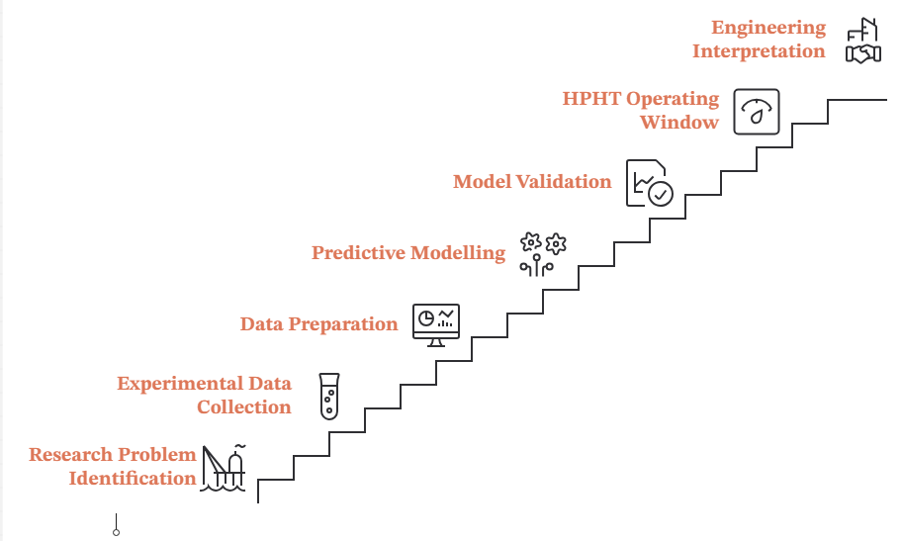
Source: Developed by the author. Note: Presents the overall petroleum engineering research workflow adopted in this study.

Figure 6.3 presents the overall research methodology framework adopted in this study. The framework illustrates the sequential progression of the research from problem identification through experimental data collection, data preparation, predictive modelling, model validation, HPHT operating-window identification, and engineering interpretation and decision support. The use of sequential research stages and clearly defined workflows promotes methodological transparency, traceability, and reproducibility, which are fundamental principles of robust engineering research (Saunders, et al.,2023; PMI, 2021).

Figure 6.4
Machine Learning Model Development, Validation and Engineering Integration Framework

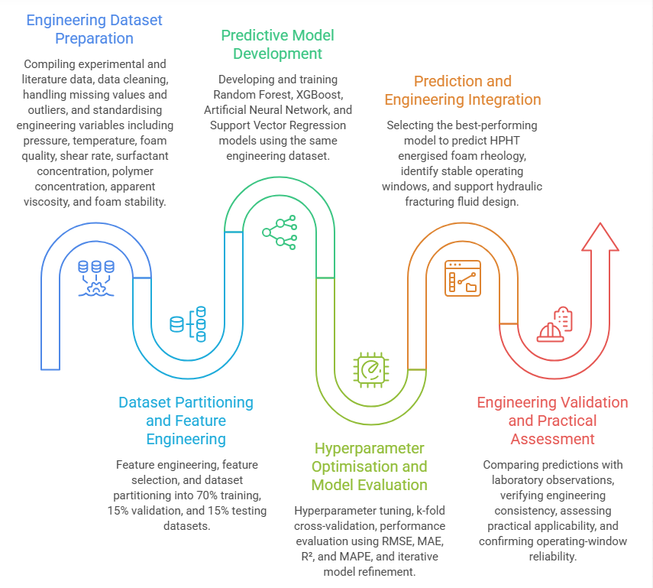
Source: Developed by the author. Note: Illustrates the machine learning workflow integrated within the proposed engineering methodology.
The predictive modelling component is further expanded in Figure 6.4, entitled Machine Learning Model Development, Validation and Engineering Integration Framework. The framework illustrates engineering dataset preparation, feature engineering, dataset partitioning, predictive model development, hyperparameter optimisation, model evaluation, engineering integration, and engineering validation. The iterative workflow follows established machine learning practice, where model refinement, performance evaluation, and validation are integral to developing robust predictive models suitable for engineering applications (Goodfellow, Bengio, & Courville, 2016; Géron, 2023).
Collectively, these four frameworks provide a comprehensive representation of the proposed research methodology. Figure 6.1 establishes the engineering problem motivating the study, Figure 6.2 demonstrates the alignment between the research problem and the proposed investigation, Figure 6.3 presents the overall research methodology, and Figure 6.4 expands the detailed implementation of the predictive modelling component. Together, these frameworks communicate the progression of the study from engineering problem identification to predictive modelling and engineering application while maintaining the central focus on petroleum engineering.
Following this overview, the proposed methodology is organised into sequential research phases, with each phase defined by clearly specified Objectives, Inputs, Activities, Outputs, and Decision Points. This structured architecture provides a systematic framework for managing the progression of the research while maintaining traceability between the research objectives, methodological activities, and expected outcomes (PMI, 2021). The sequential arrangement enables the logical progression from engineering problem identification through experimental data acquisition, data preparation, predictive modelling, model validation, uncertainty quantification, operating-window identification, and engineering interpretation.
The methodology systematically integrates experimental data acquisition, data preparation, predictive modelling, model validation, uncertainty quantification, and operating-window identification to support the development of robust predictive models, evaluation of prediction uncertainty, and petroleum engineering decision-making while facilitating future assessment of field-scale applicability (Ogbidi and Oteh, 2023). Engineering judgement and physical interpretation remain embedded throughout the workflow, ensuring that predictive modelling is guided by engineering principles and laboratory evidence rather than algorithmic performance alone.
Although Figures 6.3 and 6.4 present the methodology as a sequence of detailed research and modelling stages, these stages are implemented through five high-level engineering modules that structure the proposed investigation. The modules provide the organisational framework for the methodology, whereas the stages represent the detailed analytical and engineering activities undertaken within each module. This distinction clarifies that the machine learning implementation is embedded within, rather than separate from, the overall petroleum engineering research methodology.

6.2.2 Engineering Modules of the Proposed Methodology
To operationalise the proposed research methodology, the study is structured into five interconnected engineering modules, namely Data Compilation and Preparation (Section 6.3), Rheology and Stability Prediction (Section 6.4), Uncertainty Quantification (Section 6.5), Operating-Window Identification (Section 6.6), and Engineering Assessment (Section 6.7). Although each module addresses a distinct component of the investigation, they collectively form an integrated petroleum engineering methodology in which the outputs of one module provide the inputs for the next, thereby ensuring methodological continuity and systematic progression throughout the research.
Figure 6.5 provides an integrated overview of this modular workflow. It illustrates the sequential implementation of the five engineering modules and the associated decision gates that govern progression through the methodology. At the completion of each module, predefined engineering criteria are evaluated to determine whether the workflow should proceed to the subsequent module or return for further improvement and reassessment. This iterative stage-gate approach enhances transparency, reproducibility, and engineering rigour while ensuring that predictive modelling remains embedded within an engineering-led research framework.

Figure 6.5
Integrated Engineering Workflow and Decision-Gate Framework for the Proposed Research Methodology.
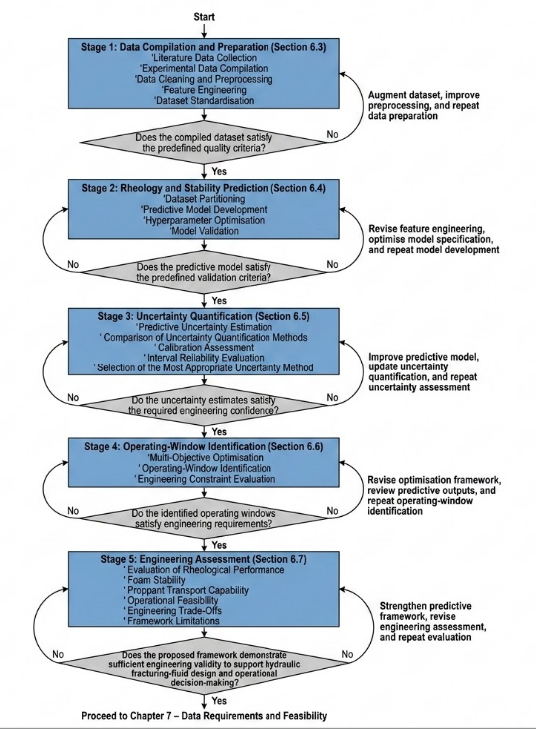
Source: Developed by the author. Note: Illustrates the five engineering modules and the decision gates guiding the proposed research workflow
The figure integrates the five engineering modules (Sections 6.3–6.7) into a sequential stage-gate workflow. Progression between modules is governed by predefined quality, validation, uncertainty, feasibility, and engineering assessment criteria, ensuring that the proposed methodology remains iterative, transparent, and engineering-driven

6.3 Data Compilation and Preparation
Because HPHT foam datasets are typically sparse, formulation-specific, and rarely formatted for computational modelling, this initial methodological module implements a targeted data extraction strategy to support project feasibility (Al-Darweesh et al., 2024).
Objective: To compile, extract, and standardise HPHT foam rheology and stability datasets suitable for predictive modelling.
Inputs: Published experimental studies, publicly available datasets, supplementary materials associated with published research, and laboratory datasets where available (Tran et al., 2023; Tran et al., 2025).
Activities: Data will be harvested primarily from peer-reviewed published studies and structured into a multi-variable feature matrix (Table 6.1). These specific variables were strategically selected because they collectively govern the operational, physicochemical, and rheological behaviour of nanoparticle-stabilised energised foams under extreme HPHT conditions (Gonzalez Perdomo and Wan Madihi, 2022; Al-Darweesh et al., 2024). To resolve inconsistencies across different independent experimental studies, rigorous dataset standardisation protocols will be applied where appropriate (Table 6.2).
Outputs: A harmonised, quality-assured dataset suitable for predictive modelling.
Decision Point: Does the harmonised dataset meet the predefined quality criteria for model development? If No, augment the dataset through additional data acquisition, improve the preprocessing procedures where necessary, and repeat the compilation and standardisation workflow. If Yes, proceed to Section 6.4: Rheology and Stability Prediction.

Table 6.1. Summary of Input and Output Variables for the Proposed Predictive Modelling Framework
Variable | Type | Unit | Engineering Significance | Selection Rationale | Key References
System Pressure | Input | MPa | Controls foam compressibility and rheological stability | Fundamental HPHT operating parameter influencing foam behaviour | Gonzalez Perdomo & Wan Madihi (2022); Jing et al. (2019)
Reservoir Temperature | Input | °C | Influences thermal degradation and apparent viscosity | Governs thermal stability and rheological response | Gonzalez Perdomo & Wan Madihi (2022); Fu & Liu (2021); Hutchins & Miller (2005)
Foam Quality | Input | % | Determines gas-liquid ratio and internal phase volume | Primary determinant of foam structure and flow behaviour | Akhtar et al. (2018); Ahmed et al. (2017)
Gas Type | Input | Category | Dictates phase compressibility (e.g., N₂ vs. CO₂) | Influences foam compressibility and stability characteristics | Wanniarachchi et al. (2017); Yekeen et al. (2018)
Gas Fraction | Input | % | Determines overall foam structure | Represents gas content affecting rheological properties | Akhtar et al. (2018); Wanniarachchi et al. (2017)
Surfactant Concentration | Input | wt% | Governs foam generation and liquid-film elasticity | Controls foam formation and stabilisation | Tran et al. (2022); Tran et al. (2023)
Nanoparticle Concentration | Input | wt% | Provides steric stabilisation at elevated temperatures | Enhances foam stability under HPHT conditions | Gonzalez Perdomo & Wan Madihi (2022); Tran et al. (2022); Tran et al. (2025)
Brine Salinity | Input | ppm | Affects surfactant solubility and ionic interactions | Influences chemical interactions within the foam system | Tran et al. (2023)
Rotational Shear Rate | Input | s⁻¹ | Drives non-Newtonian flow behaviour | Determines rheological response under dynamic flow conditions | Ahmed et al. (2017); Al-Darweesh et al. (2024
Apparent Viscosity | Output | mPa·s | Primary predictive rheological target | Principal indicator of foam flow performance | Ahmed et al. (2017); Al-Darweesh et al. (2024); Gonzalez Perdomo & Wan Madihi (2022)
Foam Half-life | Output | min | Primary predictive stability target | Measures foam stability under HPHT conditions | Tran et al. (2022); Gonzalez Perdomo & Wan Madihi (2022)
Drainage Rate | Output | % | Secondary foam stability indicator | Evaluates liquid drainage and foam decay | Tran et al. (2022); Fu & Liu (2021)
Proppant Transport Performance Indicator | Output | — | Operational assessment | Assesses the engineering effectiveness of the foam system | Fei et al. (2018); Tran et al. (2025); Goel et al. (2002)
Source: Adapted from Gonzalez Perdomo & Wan Madihi (2022); Jing et al. (2019), Fei et al. (2018); Tran et al. (2025); Goel et al. (2002), Liu (2021) Note: The proposed feature matrix represents the author's synthesis of the key variables influencing HPHT energised foam rheology and forms the basis for the predictive modelling framework.
The feature matrix presented in Table 6.1 defines the proposed input and output variables that will form the foundation of the predictive modelling framework. These variables capture the principal operational, physicochemical, and engineering factors influencing HPHT energised foam behaviour and provide a structured basis for subsequent data compilation and feature engineering. However, because these data are expected to be compiled from multiple independent experimental studies, additional preprocessing is required to ensure consistency before model development.
Following variable selection, the compiled datasets will undergo the standardisation procedures summarised in Table 6.2 to minimise inconsistencies arising from differences in reporting formats, measurement units, terminology, and experimental protocols. These preprocessing activities are intended to improve data quality and ensure that the harmonised dataset is suitable for reliable machine learning analysis and subsequent engineering interpretation.

Table 6.2 Dataset Standardisation Protocol
Data Issue | Standardisation Strategy | Key References
Variable pressure/temperature units | Uniform conversion to MPa and °C | Gonzalez Perdomo & Wan Madihi (2022); Tran et al. (2023)
Variable chemical concentration units | Uniform conversion to weight percentage (wt%) | Tran et al. (2022); Tran et al. (2023)
Missing experimental metadata | Statistical imputation where appropriate, or record removal | Géron (2023); Kuhn & Johnson (2019)
Duplicate observations | Remove duplicate records | Géron (2023); Kuhn & Johnson (2019)
Inconsistent measurement scales | Z-score normalisation or Min-Max scaling | Géron (2023); Kuhn & Johnson (2019)
Experimental outliers | Statistical anomaly detection coupled with physical engineering review | Géron (2023); Kuhn & Johnson (2019)
Inconsistent terminology | Harmonisation of variable names across disparate studies | Tran et al. (2023); Al-Darweesh et al. (2024)
Source: Adapted from Gonzalez Perdomo & Wan Madihi (2022); Jing et al. (2019), Fei et al. (2018); Tran et al. (2025); Goel et al. (2002), Liu (2021) Note: The standardisation protocol represents the proposed data preprocessing workflow for harmonising heterogeneous HPHT foam datasets compiled from multiple experimental studies. The procedures are intended to improve data consistency, comparability, and suitability for subsequent machine learning analysis.

Once the dataset has been compiled and standardised, appropriate analytical methods will be selected to develop, compare, and evaluate predictive models. Because the compiled HPHT dataset is expected to exhibit nonlinear relationships, varying data density, and potential uncertainty, multiple complementary machine learning approaches are proposed rather than relying on a single algorithm. The rationale for selecting these analytical methods is summarised in Table 6.3.
Table 6. 3 Analytical Method Selection and Justification
Method | Primary Purpose | Justification for Selection | Expected Output | Key References
Random Forest (RF) | Establish baseline predictive performance and identify important predictors | Robust to nonlinear relationships, relatively resistant to overfitting on moderate-sized datasets, and provides variable importance measures that support engineering interpretation. | Baseline predictions of apparent viscosity and foam stability; feature importance rankings. | Breiman (2001); Géron (2023)
Extreme Gradient Boosting (XGBoost) | Improve predictive accuracy for complex nonlinear relationships | Efficient gradient boosting algorithm capable of modelling complex interactions among pressure, temperature, foam quality, surfactant concentration, nanoparticle concentration, and other variables while maintaining strong predictive performance. | Enhanced deterministic predictions and comparative model performance. | Chen & Guestrin (2016); Géron (2023)
Artificial Neural Networks (ANNs) | Capture highly complex nonlinear behaviour where sufficient data are available | Considered only if dataset size and quality are adequate to minimise overfitting and improve generalisation. Included as an advanced modelling option rather than a default approach. | Advanced deterministic predictions for comparison with baseline models. | Goodfellow, Bengio & Courville (2016); Géron (2023)
Gaussian Process Regression (GPR) | Quantify predictive uncertainty for small or sparse datasets | Particularly suitable for limited experimental datasets because it naturally provides probabilistic predictions and confidence intervals while modelling nonlinear relationships. | Probabilistic predictions with uncertainty estimates. | Rasmussen & Williams (2006); Ogbidi & Oteh (2023)
Monte Carlo Dropout / Ensemble Prediction Methods | Estimate epistemic uncertainty | Applied where appropriate to quantify uncertainty arising from limited data and model parameters, thereby improving confidence in engineering decision-making. | Prediction intervals and confidence estimates. | Gal & Ghahramani (2016); Ogbidi & Oteh (2023)
Bayesian Optimisation | Identify optimal operating conditions | Efficiently searches the multidimensional design space to determine operating windows that satisfy engineering constraints while accounting for predictive uncertainty. | Candidate operating windows for HPHT hydraulic fracturing operations. | Shahriari et al. (2016); Frazier (2018)
Source: Adapted from Gonzalez Perdomo & Wan Madihi (2022); Jing et al. (2019), Fei et al. (2018); Tran et al. (2025); Goel et al. (2002), Liu (2021 Note: The analytical methods were selected for their suitability for nonlinear prediction and uncertainty quantification. Final implementation will depend on the compiled HPHT foam dataset.
The analytical methods presented in Table 6.3 represent a progressive modelling strategy, beginning with robust baseline algorithms and extending to probabilistic approaches capable of quantifying predictive uncertainty. The final selection of models will depend on the characteristics of the compiled dataset and their demonstrated predictive performance. The implementation and evaluation of these methods are described in the following section on Rheology and Stability Prediction.

6.4 Rheology and Stability Prediction
This module addresses the complex fluid dynamics of nanoparticle-stabilised energised foams as they transition from near-Newtonian to highly non-Newtonian, shear-thinning behaviour under varying HPHT shear conditions (Ghorbani, 2025).
Objective: To systematically develop and evaluate predictive models capable of mapping the nonlinear rheological behaviour and stability profiles of nanoparticle-stabilised energised foams under HPHT conditions.
Inputs: The harmonised dataset generated in Section 6.3.
Activities: To prevent unnecessary algorithmic complexity and ensure strict scope control, this phase adopts a staged modelling strategy. Initial evaluations will begin with robust and interpretable baseline models, such as Random Forest and XGBoost, to establish baseline predictive performance and investigate the coupled effects of pressure, temperature, and fluid composition (Al-Darweesh et al., 2024). Where dataset size and quality permit, more complex architectures such as Artificial Neural Networks (ANN) may also be evaluated to determine whether additional predictive performance can be achieved without significant overfitting.
Model validation will not rely solely on random point-wise splitting, as measurements from the same formulation or experimental study may be highly correlated and could overestimate predictive performance. Where permitted by the size and structure of the compiled dataset, grouped validation will therefore be applied by withholding complete formulations, experimental studies, or defined operating ranges. This will test model generalisation across unseen formulations, data sources, and HPHT conditions. Interpolation within the training domain will be distinguished from extrapolation beyond the ranges represented in the training data, with out-of-domain predictions evaluated separately and subsequently interpreted alongside the uncertainty estimates generated in Section 6.5. Random train/test splitting may be retained as a baseline comparison rather than the sole evidence of model generalisation.
Model performance will be evaluated using appropriate regression metrics, including Root-Mean-Square Error (RMSE), Mean Absolute Error (MAE), and the Coefficient of Determination (R²).
Outputs: Validated deterministic predictions of the primary targets, apparent viscosity and foam half-life together with evidence of model performance and generalisation across the evaluated validation scenarios.
Decision Point: Does the selected predictive model satisfy the predefined performance and validation criteria for reliable engineering prediction? If No, revise the feature engineering process, optimise the model specification, and repeat the model development and validation workflow. If Yes, proceed to Section 6.5 – Predictive Uncertainty Quantification.

6.5 Predictive Uncertainty Quantification
Current deterministic approaches applied to fracturing fluids output rigid point-predictions, often neglecting the underlying physical measurement sparsity typical of HPHT laboratory datasets. This module directly addresses that critical engineering limitation.
Objective: To incorporate uncertainty quantification into the predictive framework by estimating confidence intervals for the rheological predictions and supporting more reliable engineering interpretation.
Inputs: The best-performing predictive model(s) identified during the rheology and stability prediction stage (Section 6.4).
Activities: Uncertainty Quantification (UQ) will be applied exclusively to the models demonstrating the highest baseline accuracy. Crucially, this phase will explicitly decouple aleatoric uncertainty (arising from inherent experimental measurement noise and fluid variability) from epistemic uncertainty (arising from sparse laboratory data and model limitations) (Gal and Ghahramani, 2016). Depending on the characteristics of the compiled dataset, appropriate uncertainty quantification techniques, including Bayesian inference, Gaussian Process Regression (GPR), or ensemble-based prediction intervals (e.g., Monte Carlo Dropout), will be evaluated to determine the most suitable approach for estimating predictive uncertainty (Gal and Ghahramani, 2016; Ogbidi and Oteh, 2023). The candidate uncertainty quantification methods will be compared based on their calibration performance, interval reliability, predictive accuracy, and practical usefulness for supporting petroleum engineering decision-making. The method demonstrating the most appropriate balance between predictive performance, uncertainty reliability, and engineering applicability will be adopted for subsequent operating-window identification.
Outputs: Uncertainty-aware predictions, confidence intervals, and quantitative measures of predictive uncertainty for apparent viscosity and foam stability
Decision Point: Do the uncertainty estimates satisfy the predefined confidence requirements for engineering decision-making? If No, improve the predictive model and recalibrate the uncertainty quantification approach before repeating the assessment. If Yes, proceed to Section 6.6: Operating Window Identification and Engineering Optimisation.

6.6 Operating Window Identification
To translate uncertainty-aware predictions into practical engineering guidance, this module identifies the operational conditions under which nanoparticle-stabilised energised foams are expected to achieve acceptable engineering performance while maintaining acceptable predictive uncertainty.
Objective: To identify multidimensional candidate operating windows within which nanoparticle-stabilised energised foams are predicted to achieve acceptable engineering performance while maintaining acceptable predictive uncertainty for hydraulic fracturing-fluid design.
Inputs: Uncertainty-aware predictions of apparent viscosity and foam stability, together with the associated uncertainty estimates generated in Section 6.5.
Activities: Appropriate optimisation techniques, including Bayesian Optimisation where suitable, will be evaluated to support operating-window identification (Shahriari et al., 2016). Within this study, an operating window is defined as the multidimensional range of pressure, temperature, foam quality, salinity, surfactant concentration, nanoparticle concentration, and related operational variables within which nanoparticle-stabilised energised foams are predicted to achieve acceptable apparent viscosity, foam stability, and proppant-support capability while maintaining acceptable predictive uncertainty for hydraulic fracturing-fluid design. The acceptance criteria and engineering constraints will be informed by relevant experimental evidence, literature, and available design requirements. This definition establishes the operating window as an engineering decision-support tool rather than simply an optimisation outcome (Gonzalez Perdomo and Wan Madihi, 2022).
Outputs: Uncertainty-bounded candidate operating windows and proposed operational ranges to support hydraulic fracturing-fluid formulation and subsequent engineering assessment.
Decision Point: Do the identified candidate operating windows satisfy the predefined engineering requirements for HPHT hydraulic fracturing-fluid design? If No, revise the optimisation framework, review the predictive modelling outputs, and repeat the operating window identification process. If Yes, proceed to Section 6.7: Engineering Assessment.

6.7 Engineering assessment
This final module evaluates how the uncertainty-aware predictive framework can support petroleum engineering decision-making by relating the predicted rheological behaviour and identified operating windows to hydraulic fracturing-fluid performance under HPHT reservoir conditions.
Objective: To evaluate how the predicted rheological behaviour and identified operating windows can support engineering assessment of hydraulic fracturing-fluid performance under HPHT conditions.
Inputs: The proposed operating windows, predicted rheological properties, and associated uncertainty estimates generated in Section 6.6.
Activities: The engineering assessment will integrate the predicted rheological behaviour, uncertainty estimates, and identified operating windows to evaluate their practical relevance for hydraulic fracturing-fluid design under HPHT conditions. The assessment will examine predicted rheological performance, foam stability, proppant transport capability, and fracture conductivity in relation to published experimental evidence and established engineering principles (Tran et al., 2025; Fei et al., 2018). The operational feasibility of the identified operating windows will also be evaluated by considering predictive uncertainty, engineering constraints, and practical design requirements. Finally, the assessment will identify engineering trade-offs, discuss the assumptions and limitations of the proposed predictive framework, and highlight areas requiring further laboratory validation before potential field application.
Outputs: Engineering assessment of the proposed predictive framework, design recommendations for HPHT hydraulic fracturing-fluid formulation, identified engineering limitations, and recommendations for future validation and field application.
Decision Point: Does the proposed framework demonstrate sufficient engineering validity to support hydraulic fracturing-fluid design and operational decision-making? If No, strengthen the predictive framework, revise the engineering assessment, and repeat the evaluation. If Yes, proceed to 7 – Data Requirements and Feasibility.

7 Data Requirements and Feasibility
Given the limited availability, size, heterogeneity, and structure of HPHT foam rheology and stability datasets, this research adopts a realistic data strategy that prioritises accessible sources and avoids dependence on proprietary or otherwise unavailable data.
This research acknowledges that HPHT foam rheology and stability datasets in the existing literature are frequently small, formulation-specific, heterogeneous, and rarely reported in a format directly suitable for machine learning applications (Al-Darweesh et al., 2024). Consequently, the primary data strategy will begin with available published experimental datasets and the systematic extraction, structuring, digitisation, and standardisation of relevant HPHT foam measurements (Tran et al., 2023). Publicly available datasets and supplementary research materials will be incorporated where suitable. Research-group datasets will be considered only where they are available, relevant, and appropriately approved for use.
The computational modelling strategy will be adapted to the size, quality, structure, and variable coverage of the resulting master dataset. Selected machine learning and uncertainty quantification methods will be evaluated based on the available data characteristics, with model complexity restricted where data availability is insufficient to support more complex model architectures (Ogbidi and Oteh, 2023).
Ultimately, the feasibility of subsequent predictive modelling will be assessed on the basis of dataset adequacy rather than assumed in advance. If the compiled dataset is deemed insufficient in terms of size, completeness, variable coverage, or experimental diversity, the data search and extraction strategy will be broadened, and the modelling scope will be adjusted to align with the available physical evidence.

8. Expected Contributions
This research is expected to contribute to petroleum engineering through the data-driven prediction and engineering assessment of nanoparticle-stabilised energised fracturing foams under HPHT conditions. The expected contributions are aligned with the research objectives and proposed methodology.
8.1 Structured HPHT Foam Data Resource
Through the systematic extraction, digitisation, harmonisation, and standardisation of available experimental data, the research is expected to produce a structured dataset and reproducible data-preparation approach for the analysis of heterogeneous HPHT foam rheology and stability data.
8.2 Predictive Framework for HPHT Foam Rheology and Stability
The study is expected to develop and evaluate a data-driven framework for predicting the apparent viscosity and foam stability of nanoparticle-stabilised energised foams across varying formulation and HPHT operating conditions.
8.3 Uncertainty Quantification and Model Reliability Assessment
The research is expected to extend deterministic prediction by quantifying predictive uncertainty and assessing model reliability under sparse and extrapolated HPHT conditions. This will provide a basis for interpreting model predictions with greater awareness of their confidence and limitations.
8.4 Candidate Operating-Window Identification
The study is expected to identify uncertainty-bounded candidate operating windows representing combinations of pressure, temperature, foam quality, salinity, surfactant concentration, and nanoparticle concentration associated with acceptable rheological and stability performance under defined engineering constraints.
8.5 Engineering Assessment for Fracturing-Fluid Design
The research is expected to evaluate the implications of predicted foam rheology, stability, and candidate operating windows for fracturing-fluid design and the downstream assessment of proppant suspension and transport. This assessment will connect the predictive outputs to relevant petroleum engineering considerations without treating the models as substitutes for experimental validation or engineering judgement.
Collectively, these contributions are expected to provide an uncertainty-aware predictive framework for estimating apparent viscosity and foam stability, quantifying prediction uncertainty, and identifying candidate operating windows for nanoparticle-stabilised energised foams under HPHT conditions. The resulting outputs are intended to support further laboratory and engineering evaluation rather than provide automatically field-ready design decisions.

9. Scope and Limitations
This research is bounded to the evaluation and prediction of nanoparticle-stabilised energised fracturing foams under HPHT conditions. In direct alignment with the research objectives, a clear distinction is maintained between primary predictive targets and downstream engineering applications. The machine learning framework is scoped to predict apparent viscosity and foam stability, operationalised primarily through foam half-life, as the central predictive targets (Gonzalez Perdomo and Wan Madihi, 2022). Proppant transport assessment and operating-window identification are treated as downstream engineering applications informed by these predictions (Tran et al., 2025).
While the study will evaluate the engineering implications of foam rheology and stability for proppant suspension and transport, it will not attempt to develop a fully coupled three-dimensional hydraulic fracturing simulator. Instead, the framework will identify uncertainty-bounded candidate operating windows to support further laboratory evaluation, engineering assessment, and existing fracture-design workflows. The empirical modelling is also constrained by the availability, size, heterogeneity, variable coverage, and formulation specificity of accessible HPHT foam rheology and stability datasets (Al-Darweesh et al., 2024).

10. Alignment with My Background
This proposed research sits at the intersection of predictive analytics, engineering systems, and petroleum engineering. My academic background, which includes a Master of Research in Artificial Intelligence with Distinction, provides a strong foundation in Bayesian optimisation, uncertainty quantification, and time-series data modelling. These capabilities are relevant to the computational components of the proposed research, particularly the prediction of foam rheology and stability, assessment of model uncertainty, and identification of candidate operating windows.
Professionally, my experience as a Research Assistant on a UKRI-funded Knowledge Transfer Partnership, where I contributed to the development of IoT-enabled predictive monitoring systems for high-pressure subsea hydraulic networks, provides relevant experience in analysing complex engineering systems involving pressure, operating variability, monitoring, and uncertainty. Although this experience is not equivalent to petroleum engineering or hydraulic fracturing-fluid design, it provides a transferable engineering systems perspective for investigating fluid behaviour and predictive performance under demanding operating conditions. My membership of the Society of Petroleum Engineers (SPE) further reflects my ongoing engagement with the petroleum and energy sector.
At the same time, I recognise that petroleum engineering, foam rheology, and hydraulic fracturing-fluid design are specialised areas in which I will need to deepen my knowledge during the early stages of candidature. My existing strengths lie primarily in artificial intelligence, predictive modelling, uncertainty quantification, and engineering systems. The doctoral programme will therefore require deliberate development of the domain-specific knowledge needed to apply these capabilities appropriately to nanoparticle-stabilised energised foam systems under HPHT conditions.
This interdisciplinary development is an important part of the proposed research and will help ensure that the computational methods are informed by relevant physical principles, experimental evidence, and petroleum engineering judgement.

11. References
Ahmed, S., Elraies, K.A., Forooozesh, J., Bt Mohd Shafian, S.R., Hashmet, M.R., Hsia, I.C.C. and Almansour, A. (2017) 'Experimental investigation of immiscible supercritical carbon dioxide foam rheology for improved oil recovery', Journal of Earth Science, 28(5), pp. 835–841.
Ahmed, S., Elraies, K.A., Hashmet, M.R. and Hanamertani, A.S. (2017) 'Viscosity models for polymer free CO2 foam fracturing fluid with the effect of surfactant concentration, salinity and shear rate', Energies, 10(12), p. 1970.
Akhtar, T.F., Ahmed, R., Elgaddafi, R., Shah, S. and Amani, M. (2018) 'Rheological behavior of aqueous foams at high pressure', Journal of Petroleum Science and Engineering, 162, pp. 214–224.
Al-Darweesh, J., Aljawad, M.S., Tariq, Z., Alajmei, S., Yan, B. and Kamal, M.S. (2024) 'Prediction of foam rheology models parameters utilizing machine learning tools', ACS Omega, 9(18), pp. 20397-20409.
Breiman, L. (2001). Random Forests. Machine Learning, 45(1), 5–32.
Chen, T., & Guestrin, C. (2016). XGBoost: A scalable tree boosting system. Proceedings of the 22nd ACM SIGKDD International Conference on Knowledge Discovery and Data Mining, 785–794.
Creswell, J. W., & Creswell, J. D. (2023). Research Design: Qualitative, Quantitative, and Mixed Methods Approaches (6th ed.). Sage.
Fei, Y., Johnson Jr, R.L., Gonzalez Perdomo, M.E., Haghighi, M. and Pokalai, K. (2018) 'Experimental and numerical investigation into nano-stabilized foams in low permeability reservoir hydraulic fracturing applications', Fuel, 213, pp. 133-143.
Frazier, P. I. (2018). A tutorial on Bayesian optimization. arXiv preprint arXiv:1807.02811
Fu, C. and Liu, N. (2021) 'Rheology and stability of nanoparticle-stabilized CO2 foam under reservoir conditions', Journal of Petroleum Science and Engineering, 196, p. 107671.
Gal, Y. and Ghahramani, Z. (2016) 'Dropout as a Bayesian approximation: Representing model uncertainty in deep learning', Proceedings of the 33rd International Conference on Machine Learning (ICML), 48, pp. 1050-1059.
Ghassemzadeh, S., Gonzalez Perdomo, M.E., Haghighi, M. and Abbasnejad, E. (2021) 'A data-driven reservoir simulation for natural gas reservoirs', Neural Computing and Applications, 33(18), pp. 11777-11798.
Ghorbani, M.A. (2025) 'Machine learning-based derivation of a multi-variable implicit viscosity model for non-Newtonian fluids'. Master's thesis, Politecnico di Torino.
Gonzalez Perdomo, M.E. and Wan Madihi, S. (2022) 'Foam based fracturing fluid characterization for an optimised application in HPHT reservoir conditions', Fluids, 7(5), Article 156.
Hutchins, R.D. and Miller, M.J. (2005) 'A circulating foam loop for evaluating foam at conditions of use', SPE Production & Facilities, 20, pp. 286–294.
Jing, Z., Feng, C., Wang, S. and Xu, D. (2019) 'Effects of temperature and pressure on rheology and heat transfer among bubbles in waterless CO2-based foam fracturing fluid', Journal of Natural Gas Science and Engineering, 63, pp. 18–26.
Kuhn, M. and Johnson, K. (2019) Feature Engineering and Selection: A Practical Approach for Predictive Models. Boca Raton, FL: Chapman & Hall/CRC.
Lundberg, S.M. and Lee, S.I. (2017) 'A unified approach to interpreting model predictions', Advances in Neural Information Processing Systems, 30, pp. 4765–4774.
Lv, Q., Li, Z., Li, B., Li, S. and Sun, Q. (2015) 'Study of nanoparticle–surfactant-stabilized foam as a fracturing fluid', Industrial & Engineering Chemistry Research, 54(38), pp. 9468–9477.
Maxwell, J. A. (2013). Qualitative Research Design: An Interactive Approach (3rd ed.). Sage.
Ogbidi, L. and Oteh, B. (2023) 'Reservoir uncertainty quantification methods supporting reliable forecasting across varying geological and operational scenarios', International Journal of Advanced Multidisciplinary Research and Studies, 3(6), pp. 2345-2362.
PMI. (2021). A Guide to the Project Management Body of Knowledge (PMBOK® Guide) (7th ed.). Project Management Institute.
Princen, H.M. and Kiss, A.D. (1989) 'Rheology of foams and highly concentrated emulsions: IV. An experimental study of the shear viscosity and yield stress of concentrated emulsions', Journal of Colloid and Interface Science, 128(1), pp. 176–187.
Rasmussen, C. E., & Williams, C. K. I. (2006). Gaussian Processes for Machine Learning. MIT Press.
Saunders, M., Lewis, P., & Thornhill, A. (2023). Research Methods for Business Students (9th ed.). Pearson
Shahriari, B., Swersky, K., Wang, Z., Adams, R.P. and de Freitas, N. (2016) 'Taking the human out of the loop: A review of Bayesian optimization', Proceedings of the IEEE, 104(1), pp. 148-175.
Sinha, V., Ahmed, R., Akhtar, T., Shah, S. and Amani, M. (2019) 'Rheology and hydraulics of polymer-based foams at elevated temperatures', Journal of Petroleum Science and Engineering, 180, pp. 330–346.
Tran, T., Gonzalez Perdomo, M.E., Haghighi, M. and Amrouch, K. (2022) 'Study of the synergistic effects between different surfactant types and silica nanoparticles on the stability of liquid foams at elevated temperature', Fuel, 315, Article 122818.
Tran, T., Gonzalez Perdomo, M.E., Haghighi, M. and Amrouch, K. (2023) 'Experimental study of the effects of salinity on nanoparticle-surfactant foams for fracture stimulation application', Journal of Natural Gas Science and Engineering, 115, Article 205007.
Tran, T., Nguyen, G.H., Gonzalez Perdomo, M.E., Haghighi, M. and Amrouch, K. (2025) 'Simulation study of the effects of foam rheology on hydraulic fracture proppant placement', Processes, 13(2), Article 378.
Wanniarachchi, W.A.M., Ranjith, P.G. and Perera, M.S.A. (2017) 'Shale gas fracturing using foam-based fracturing fluid: a review', Environmental Earth Sciences, 76, Article 91.
Yekeen, N., Padmanabhan, E. and Idris, A.K. (2018) 'A review of recent advances in foam-based fracturing fluid application in unconventional reservoirs', Journal of Industrial and Engineering Chemistry, 66, pp. 45-71.
Zhang, Y.-L., Yu, Z.-C. and He, C. (2025) 'Uncertainty-aware neural networks with manual quality control for hydraulic fracturing downhole microseismic monitoring', Petroleum Science, 22, pp. 4520–4537

